Web-Based (Online) Studies
You may set up studies that are web-based (online), and these studies may be set up internally in the system (as a survey) or outside the system.

There are a few things to note about web-based studies:

- Once you indicate to the system that the study is web-based, you will not be able to change it so that it is no longer web-based (but you can deactivate or delete the study). So, make this choice carefully
- Web-based studies are typically setup so there is one timeslot, and that timeslot contains the maximum number of participants you would like to participate, and the last date and time when they can participate (often, this is the end of the term). It is not recommended that you set up multiple timeslots for a web-based studies (it confuses participants), though the system will support it. It is acceptable to have multiple timeslots where more than one is not active at a time. For example, one could have had a deadline date of the end of the previous semester (and thus is currently in the past), while the current timeslot has a deadline date of the end of the current semester (i.e., in the future).
- It is generally assumed that participants will participate in an online study shortly after they sign up. Because of this, the system will expect you to grant credit to them soon after they sign up. If you are creating an online survey within the system, credit will be granted automatically, immediately after the participant completes the survey.

Throughout the sign-up process, participants are notified that the study is web-based.

If the study is not administered by the system, then participants are not given the URL for the website until they have signed up, to ensure they do complete a sign-up in the system for the study. They can see the URL after sign-up, and up until the timeslot they signed up for is still in the future. Once the timeslot they have signed up for is in the past, they no longer have access to the study URL. This is done to prevent participants from accidentally clicking on the URL in a subsequent semester and participating in the study twice. This restriction regarding viewing the study URL applies only to participants, and only to web-based studies administered outside the system.

Online survey studies (surveys administered by the system) are discussed in great detail later in this document. Please read it carefully before setting up an online survey study.

For web-based studies administered outside the system, you will want to develop some method of linking the participant’s sign-up in the system to your online study, so you know who to grant credit to. One way to do this is to ask the participant’s name (or some other identifying information) that will make it easy to locate their sign-up within the system and grant them credit once they have completed your online study.

Online Survey Studies Administered by the System

Introduction
The system includes a rather extensive online survey feature. It allows you to set up an online survey as a study within the system, and participants who sign up for the study will be asked to immediately complete the survey. Upon their completion of the survey, they will be granted credit automatically by the system. You may then analyze their survey responses on an individual basis, or download the raw data across all participants who completed the survey, for further analysis. There is a slight chance that you may notice a discrepancy in the number of responses when analyzing a single question compared to downloading the entire set of responses. This can occur if a participant is currently taking the survey, but has not completed it. Their data is included in the single-question analysis (when available) but not in the full download of responses, as there is not a full set of data for an in-progress participant. The system will prevent participants from completing the survey more than once, so there is no risk of duplicate entries for the same participant.

To comply with research ethics guidelines, the participant is given the opportunity to withdraw from the survey at any time. If they withdraw, they are taken to a form where they can submit any comments (this is optional), and their withdrawal is then noted and all their responses are deleted. The researcher receives an email when this occurs, with some other information, including how much time was spent on the survey, and how many questions were answered. You should then grant credit to the participant as appropriate.

There is a space to provide closing text for the survey, which is displayed to participants after they successfully complete the survey (after they have saved all their responses and cannot go back). This is an ideal place to include any relevant debriefing information.

The online survey feature is rather complex due to the many features it contains. In addition, your ability to modify the survey after participants have started to take the survey is quite limited. Because of this, you should plan out your survey well in advance, to make sure it is finalized before you make it available to participants. Do not hesitate to contact the administrator if you have any questions. You may find it helpful to plan out the survey on paper before entering it into the system.

A survey may have an unlimited number of sections and an unlimited number of questions per section, though we recommend limiting surveys to fewer than 300 total questions and 15 sections, to reduce participant fatigue. This can be an issue since they must complete the survey all at once. The system will make participants aware that their session may time out because of inactivity, in cases where the survey contains many sections that have more than 15 questions (since participants are likely to spend a lot of time on those sections and thus risk being logged out for inactivity).

Questions may be free-entry (requiring the participant to type in an answer) or multiple-choice (pick only one or pick many from the list of choices). You may also specify that the system computes a participant’s results for an entire section, as either a section sum or average score. This computed sum or average can be computed only for numeric, multiple-choice (pick only one) questions in the section. Such a computation is often useful when a participant’s aggregate score is more important, such as with a depression battery.

For free-entry questions where the participant is asked to enter a free-form text answer, the size of the entry field (as it is displayed) cannot be resized in terms of dimensions (only by length). Participants may enter up to 255 characters in their response.

Sections can be displayed in a specified order or random order, or a combination of both. Every section may contain introductory text introducing the section, and the survey itself may also have introductory text introducing the survey, as well as closing text that is displayed upon completion of the survey. You may specify that questions within a section are displayed in random order. If you do not specify random ordering for questions in a section, then the questions will be displayed (in each section) in the order they were entered and cannot be reordered later. Multiple choice questions can have their choices displayed in the entered order or random order (this is specified on a per-question basis). Multiple choice question choices can be displayed horizontally (across the page) or vertically (down the page).

It is important to realize that while the survey feature is quite extensive, there are some things it does not support. It cannot do timings, where the speed of a participant’s response (typically in milliseconds) to each question needs to be measured. It also cannot do branching, where the questions being presented to a participant will vary depending on their answer to other questions within that same survey (an example being asking a question like “Do you smoke cigarettes?” and then presenting a different set of questions based on their response). The reason advanced features like this are not currently supported is that our software is primarily a subject pool software product that happens to have an online survey feature within it. We asked our customers which features in an online survey were most important to them, and those features exist within the product. There are numerous products on the market specifically for doing online surveys (with no subject pool component), which contain more advanced features, and can easily be linked to from the Sona Systems product by setting up your study as an online study conducted outside the system. One such tool is Survey Gizmo and you can register for a free account here: http://www.surveygizmo.com/free-student-account/

Creating or Modifying a Survey
To create a survey, first create an online survey study. After you create it, you will see the option Update Online Survey when you view the study information. You may not create 2-part online survey studies.

It is important to note that while you are making changes to a survey, it is deactivated so participants may not participate in it. When you go to the Finalize Survey option after you have finished your work with the survey, you will have the opportunity to save your changes and make the survey active (available to participants) or inactive (not available to participants). You should always choose the Finalize Survey option when you finish your work with the survey, as the system saves all changes and computes some other important data when you finalize the survey. If you would like to continue work on the survey at a later date, you should still choose the Finalize Survey option to ensure your changes during the current session are properly saved (most likely you would choose to keep the survey inactive in this situation).

General Survey Information
Choose the General Information option (if creating a new survey, this is the first page you will see) to provide some basic information about the survey. The fields are explained below:

Field | Description
Introductory Text | Optional, maximum 10,000 characters. Provide a set of text that will be displayed when a participant starts the survey. You may include HTML in this area, but please be sure you know what you are doing. If you would like to add a carriage-return (paragraph break), simply type in “<p>” (without the quotes). When you first create the online survey, the system will automatically insert some basic default text in this area. You may change any of this text as much as you like – the system will not change it back later as long as you save your changes.  This is a good place to place any text for informed consent purposes. You may view how this text is displayed to participants by saving it, then going to Preview Introductory Text, which is available from the Section List page.
Closing Text | Optional, maximum 7,000 characters. Provide a set of text that will be displayed after a participant completes the survey and saves their responses. This is an ideal place for debriefing information. You may include HTML in this area, but please be sure you know what you are doing. If you would like to add a carriage-return (paragraph break), simply type in “<p>” (without the quotes).  You may view how this text is displayed to participants by saving it, then going to Preview Closing Text, which is available from the Section List page.
Display sections in random order? | You may specify a specific ordering for sections, have the system randomize the order for all sections, or specify the order of some sections, and a random order for other sections. If you specify the order for only some sections, you may also specify, for each section, whether it should be displayed before or after the random-ordered sections. The system does not keep track of the random ordering for sections for each participant.
Participant response review/change | If set to Yes, then participants may review and change their responses just before they complete the online survey. They are given this opportunity after they complete the last section of the survey, and before any closing text is shown. At this point, they can see all their responses and go back to any section to change their responses. Once they complete the online survey, they cannot go back at a later date and change any responses.  It may be useful to set this option to No (so that they are not allowed to review or change their responses at the end of the survey) if sections are somehow dependent on one another, such that allowing participants to change their responses may affect the integrity of data collection.

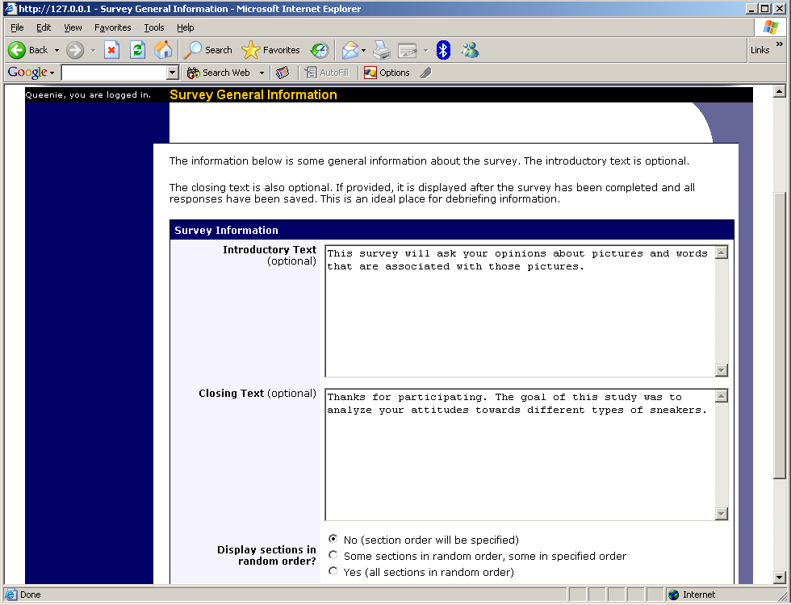
Survey General Information

Section List
Depending on if you are adding or editing the survey, you will be taken to the list of sections for the survey. Here, you can change the order that sections will be displayed (if you have not enabled full random section ordering for the survey), and see a quick review of each question. From here, you can add a question to any section and edit any question. To add a new section, choose the Add a New Section choice at the bottom of the page.

If you have enabled partial random section ordering, then you can specify a section order for the sections you would like to be displayed in a specified order. For the sections you would like to be displayed in random order, leave the Section Order area blank. When you specify a section order, use each number once, and use the numbers 1-98 if you would like the section to be displayed before the random-ordered sections, and the numbers 100-199 if you would like the section to be displayed after the random-ordered sections. Be sure to use each number only once, or leave the number blank to make the section part of the random-ordered section. Sometimes it is useful to use partial random ordering if you want to ask basic (e.g. demographic) information in the first few sections, while asking more analytical questions in the random-ordered sections. Likewise, you may want to ask about the previous random-ordered sections after they are completed. It is not possible to intersperse ordered sections within the set of random sections, like having 2 ordered sections, then 3 random sections, the 1 ordered section, then 2 random sections, etc. The random sections are treated as an entire block of sections, and other sections cannot be placed at specific places within that block.

There is also a Preview Section option so you may preview the survey as participants will see it.

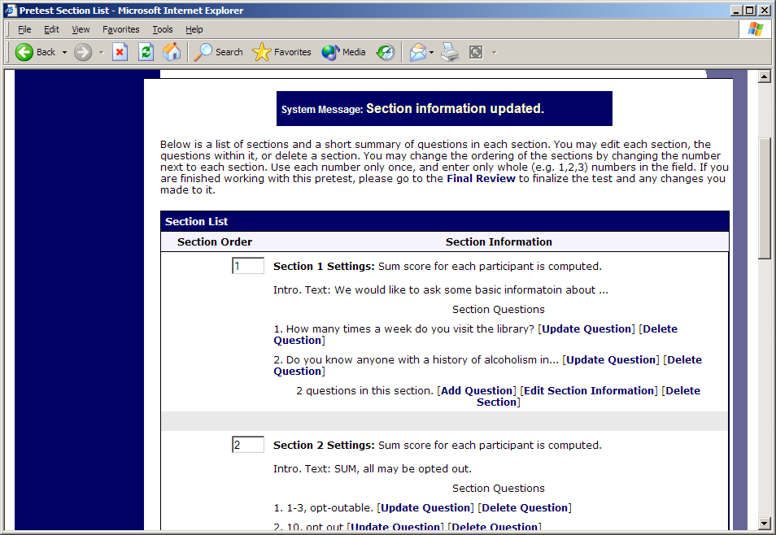
Survey Section List

Adding or Modifying a Section
To add a new section, choose the Add New Section link at the bottom of the Section List page. To modify an existing section, choose the Edit Section Information link next to the section you would like to modify, from the Section List page.

There are three pieces of information you may provide for each section. First, you may specify some introductory text to be displayed at the beginning of the section. When participants take the survey, they view one section at a time, and all the questions in that section. The introductory text may be helpful in explaining the purpose or topic of the questions in that section. You may include HTML in this area, but please be sure you know what you are doing. If you would like to add a carriage-return (paragraph break), simply type in “<p>” (without the quotes). The introductory text is limited to 15,000 characters.

You may choose if the questions for that section are displayed in random order or the order in which they are entered.

You may also choose to have the system compute a section sum or average (for each participant) for the section. These scores are computed only for all the multiple-choice, numeric questions in a section. Think carefully about setting this value, because you are very limited in your ability to change it after participants have started to take the survey.

Computed section sums or means are often useful when all the questions are using a unidimensional scale (1-5, for example), but a participant’s average score response to the section is more useful to account for their outlier responses.

Depending on if you are editing or adding a section, after you save your changes, you will be taken to a page to add a new question or to the section list.

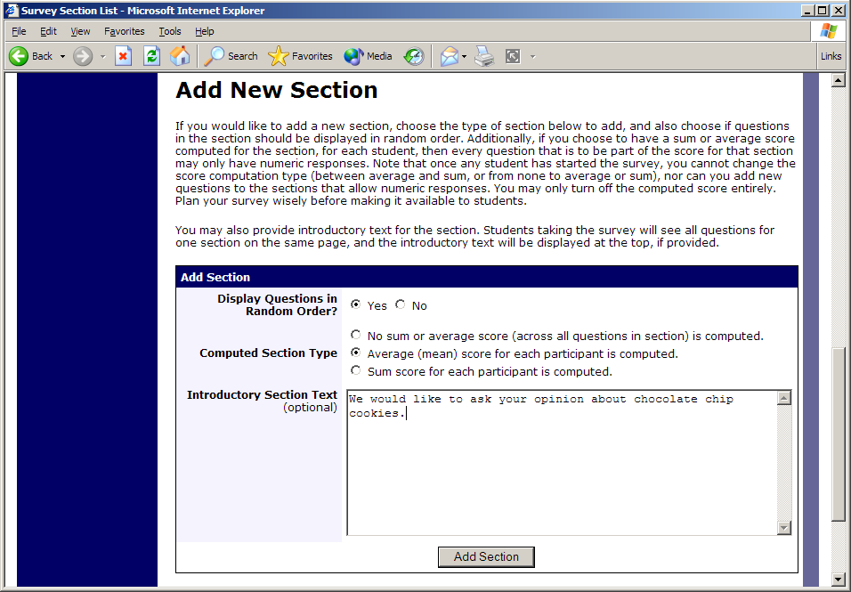
Add New Section

Adding or Editing a Question
To add or edit a question, choose the appropriate choice from the Section List, next to the desired section. Questions will be displayed in the order they are added to a section, or in a random order, depending on the section settings. Questions cannot be reordered after they are added, so this should be planned carefully. Depending on the state of the section and if participants have taken the survey, some options will be automatically set for you, and not changeable. All fields must be filled out.

Field | Description
Question Text | The text for the question. This will be displayed above each question’s choices. Maximum 15,000 characters.
Abbreviated Question Name | A 15-character label for the question. This is not displayed to participants and is used to name the columns that appear when the data is exported in CSV format. Many statistical analysis programs limit column names to 15 characters.
Question Type | Multiple Choice (select one), Multiple Choice (select many) or Free Entry. If the section has a computed average or sum, you may be limited in your ability to add Multiple Choice (select one) non-numeric questions. Free entry choices may contain a response up to 255 characters in length.
Display length of Free-Entry field | Specifies the length (size) of a free-entry field when it is displayed. Acceptable values for this setting are 5-85, and the field will always allow participants to type in up to 255 characters. The height of the field cannot be adjusted, and this setting only applies to Free Entry questions.
Display choices in random order? | If set to Yes, the choices for this question will be displayed to participants in a random order. This option only applies to multiple choice questions.
How should the choices be displayed? | Horizontal (across the page) or vertical (down the page) are the two options for how the choices for a multiple-choice question should be displayed. Often, the horizontal display is effective when the question involves a scale. This setting applies only to multiple-choice questions.
Can participants decline to provide an answer for this question? | If set to Yes, participants will see a choice below this question that allows them to opt out of answering the question. If set to No, they must answer the question. The default when adding a new question (not copying an existing question or section) is set to Yes for ethical compliance.
Are all choices numeric? | If set to Yes, all choices must be numeric whole numbers (e.g. 1, -2, 10). This only applies to multiple choice questions. Sections with a computed section sum or average may not contain non-numeric multiple choice (select many) questions.
Display numeric value? | If set to No, the numeric value of the choice is not displayed to participants. This only applies to numeric, multiple-choice questions where each choice includes both a numeric value and associated text (e.g. “5 Strongly Agree”). This is useful when running a reverse scale.

If the question is a multiple choice question, you must also fill out the choices section that is part of the same form. A minimum of 1 choice must be provided for the question. Each choice may be up to 255 characters in length. If the question is specified as numeric, you must provide a numeric choice, and that choice must be a whole number (e.g. -5, 1, 0, 349). If you would like to provide descriptive text to accompany each numeric choice, you may do so by typing in the numeric choice and leaving one blank space after it, then typing in the descriptive text, for example: “5 Strongly Agree”. If you provide descriptive text along with the numeric choice, then you have the option of hiding the numeric value from participants, by choosing No to the “Display numeric value?” setting for the question. This is useful in reverse scale or other situations where the numeric value for the choices is not important.

If the choices you specify when adding a question do not conform to the configuration of the question (e.g. specify a non-numeric choice for a numeric question), the system may change the question configuration to ensure that the choices are then valid.

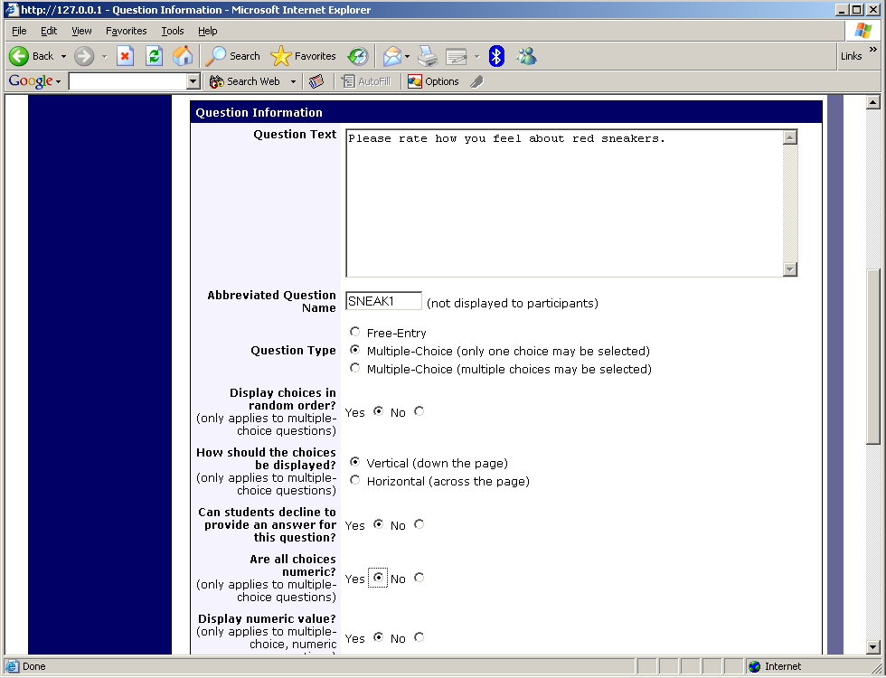
Edit a Question

Copying a Section
You may copy a section from any of your own surveys into your current survey, by choosing Copy From an Existing Section in the Section List. You will see a list of eligible surveys to copy from. After you choose which survey to copy from, you will see a list of eligible sections in that survey. Once you choose a section, it will be copied into the survey you are currently editing. You may copy only one section at a time, because of the system performance impact when copying sections.

Copying a Question
For multiple-choice questions, it is often the case that many questions have the same measures (choices). To make entry of similar questions easier, you may use the Copy Question feature to copy a question. Such an option is only available for multiple choice questions. To copy a question, select the question you would like to copy (when viewing the Section List). You will then be taken to a list of sections where you may copy this question to (the default is set to the section the question came from). After you decide which section you would like to copy the question to, you will be taken to a page where you can make any final changes to the copy of the question before saving it.

Saving Your Changes
When you are done, you should go to the Final Review and save your changes. Even if you plan to do further editing of the survey later, it is imperative that you go to the Final Review step, as the system needs to save certain special changes and make some computations. If you do not want participants to participate in the survey yet, you can save changes but keep the survey inactive. When you save your changes, it may take a moment to save all the changes, as the system is performing a number of computations on the survey. Please be patient, as these computations are done to make performance for participants as fast as possible. The system tracks which user last made the survey active or inactive and when they did this, and this is displayed on the setup page.

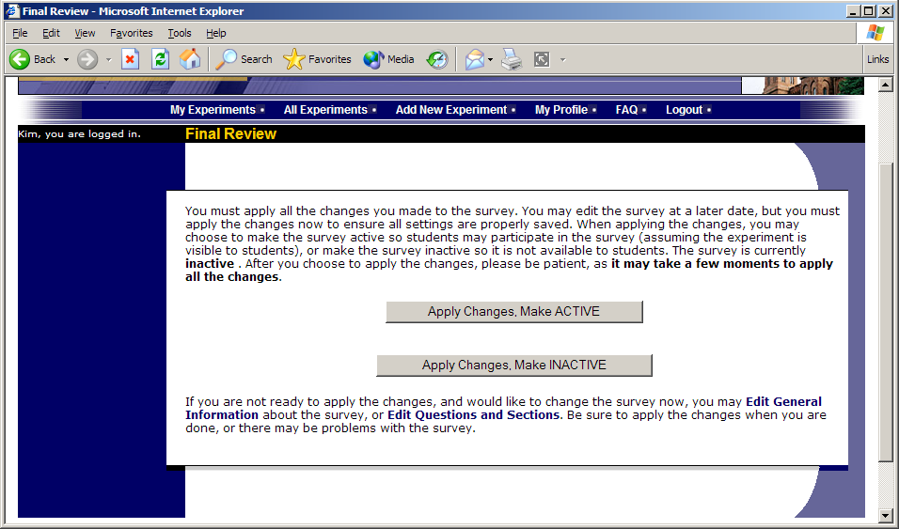
Saving Survey Changes

Viewing a Survey as a Participant
If you would like to see how the survey will be displayed to participants, that can easily be done while setting up the survey. Next to each section (in the section list), there will be a Preview Section link so you can view the section exactly as participants would see it. You may also view how the introductory and closing text will appear to participants, by choosing the Preview Introductory Text and Preview Closing Text options which appear on the Section List page.

Participants will see a basic progress display on the top right corner of each page, listing the section they are on (ordinal counting), and how many sections total are in the survey. When using Preview Section, you will see this progress display as well, except the current section number will appear as “X” in preview mode since it is not an actual participant taking the survey (and randomization of section order may be involved).

Participant Withdrawal from a Survey
At any time while participating in the survey, participants have the option to withdraw from the survey. A Withdraw button will appear in the top right corner of each page.

When a participant withdraws, they have the option to withdraw without the option to receive credit, or with the option to receive credit.

If they choose to withdraw without the option to receive credit, all their survey responses as well as the record of their sign-up will be deleted. Participants are told that this option should be used if they want to later participate in the survey. In other words, it would likely be used when a participant starts a survey but realizes they won’t be able to complete it at the moment, but would like the opportunity to participate later. No notification to researchers is sent in this scenario.

If they choose to withdraw with the option to receive credit, then all their survey responses will be deleted, but a record of their sign-up will be kept and it will be in awaiting action state. The researcher will receive an email about the withdrawal, as well as some basic information about how far along the participant was when they chose to withdraw (both in time and number of questions). This information is provided as some schools have a policy of granting credit for early withdrawals based on time spent or percentage completion. Participants also have the option of including a message that will be sent to the researcher to explain their withdrawal, but such a message is not mandatory. The researcher should then grant credit to the participant if necessary, by going to the timeslot and finding that sign-up.

Participants are informed that if they are unsure which of the withdrawal options to choose, that they should choose the withdraw option that retains their ability to receive credit.

The withdrawal option cannot be removed, as it is there to ensure compliance with research ethics guidelines.

Viewing Survey Data Usage and Deleting Survey Data
The system has a limited amount of storage space, and you are expected to download the survey data you have collected on a routine basis, and then delete it from the system. By going to View Survey Data Usage, you can see how much database space is being used. You can then download the survey data (a link is provided), and delete it from the system.

When you delete the data from the system, all survey data collected within the last 5 minutes will not be deleted, as a safety feature. This is to ensure you have had adequate time to download the survey data before deleting it.

If you choose to delete the survey data in this manner, the record of participant sign-ups will be retained, so you can ensure they do not complete the same online survey again.

Deleting a Single Participant’s Survey Responses
On rare occasions, you may want to delete a participant’s survey responses, usually so they can participate again. To do this, cancel their sign-up and that will delete their responses. Note this will also remove any credit they earned.

Analyzing Survey Responses
You may analyze a specific survey question on-screen by selecting the survey and choosing the Analyze Survey Responses option. From there, you may choose a specific question and view or download the response data. This will include data from participants who are still in the process of completing the survey, but have not yet completed it. The Download Survey Responses option, which provides the entire set of survey responses for all participants, includes only data from participants who have completed the survey, to ensure easier data analysis.

In rare cases, you may notice that a few responses for certain questions appear (or disappear from) the Analyze Survey Responses while never showing up in Download Survey Responses. What happens in this situation is that a participant started an online survey but never fully completed it or withdrew from it (they probably just closed their web browser). The system goes through all “orphaned” responses in this situation and clears them out once they are more than 2 days old.

More likely, you will want to analyze the survey data across all questions. In this case, you should choose the Download Survey Responses option.

To successfully analyze the data, you will need to download 2 sets of data. The first is the question key, which lists a unique numeric identifier for each question, along with the question text and abbreviated question name. It also includes the section number each question was in. Note the section number listed is merely a unique identifier for each section, and has no correspondence to the order in which sections were presented. Also note that section mean and sum values, if calculated, will normally be at the end of the list of questions. This data is in CSV format, and is available by clicking the Download Question Key link on the Download Survey Responses Page.

After you download the question key, you can download the survey data. The system may require that you download the data in sections if there is too much data to be downloaded as one file.

There are three options for downloading and viewing the data (both the question key and responses):
- Download as CSV File. This is the most popular option, and allows you to save the data on your computer and load it in your preferred data analysis tool.
- View On-Screen (CSV Format). This option lets you view the data on-screen instead of downloading it. The data is still displayed in CSV format, and it’s a good way to view the format of the data and ensure all the data you expect is there. Often with larger datasets, downloading and viewing the data with some tools (like Excel) may make it appear as if not all the data is there, when in reality it’s a limitation of the tool and not a problem with the data download. The on-screen option is also useful if data was collected in a language that uses Unicode character sets, like Hebrew.
- View On-Screen (Table Format). This option provides an easy way to view the data on-screen (to visually analyze the data) but is not very useful for purposes of loading the data into an analysis tool.

The data is presented as one row per respondent, with each of their responses in a different column. The first row includes the column headings, and the column heading maps to the abbreviated question name. Since there is no facility to specify an abbreviated question name for the computed section sum/mean item, the system automatically assigns a unique name to those columns. The naming convention is SECXXX where XXX maps to the system’s internal section identifier for that section (section_id). You can use the question key to determine which question maps to which column. The data also includes the exact time the participant started and completed the online survey. You can use any common data analysis tool to compute how long it took the participant to complete the survey, using this information. There is also a column listing how many minutes it took the participant to complete the survey, rounded to the nearest minute.

There will be an option to include only the numeric response portion of questions that are multiple-choice with numeric choices. This is useful if the numeric question was set up with associated text, but that text should not be included in the analysis file. One example would be where the response selected was “5 Strongly Agree” but only the number 5 (and not the associated text) is useful during analysis. If you choose this option and download data and find that the associated text is included with the numeric response, then have a closer look at the survey – most likely the question was not actually set up as a numeric question. The easiest way to deal with this downloaded data is to use a data analysis tool to do a search and replace to change the response in your downloaded data into a numeric format. Your IT department can provide assistance with such tools.

If your survey has a lot of questions (and thus columns in the output file), you may have trouble loading the data with some spreadsheet programs, which are not equipped to handle such large datasets. Your best option is to use a full-feature statistical analysis packages, like SPSS or SAS. Those packages handle large CSV-format data imports with ease. Your IT department can help you to select the best tools. In particular, Excel has trouble dealing with datasets with more than 250 questions (columns).

